**SUPPLEMENTAL MATERIAL:** low-cost electromyography: validity against a commercial system depends on exercise type and intensity

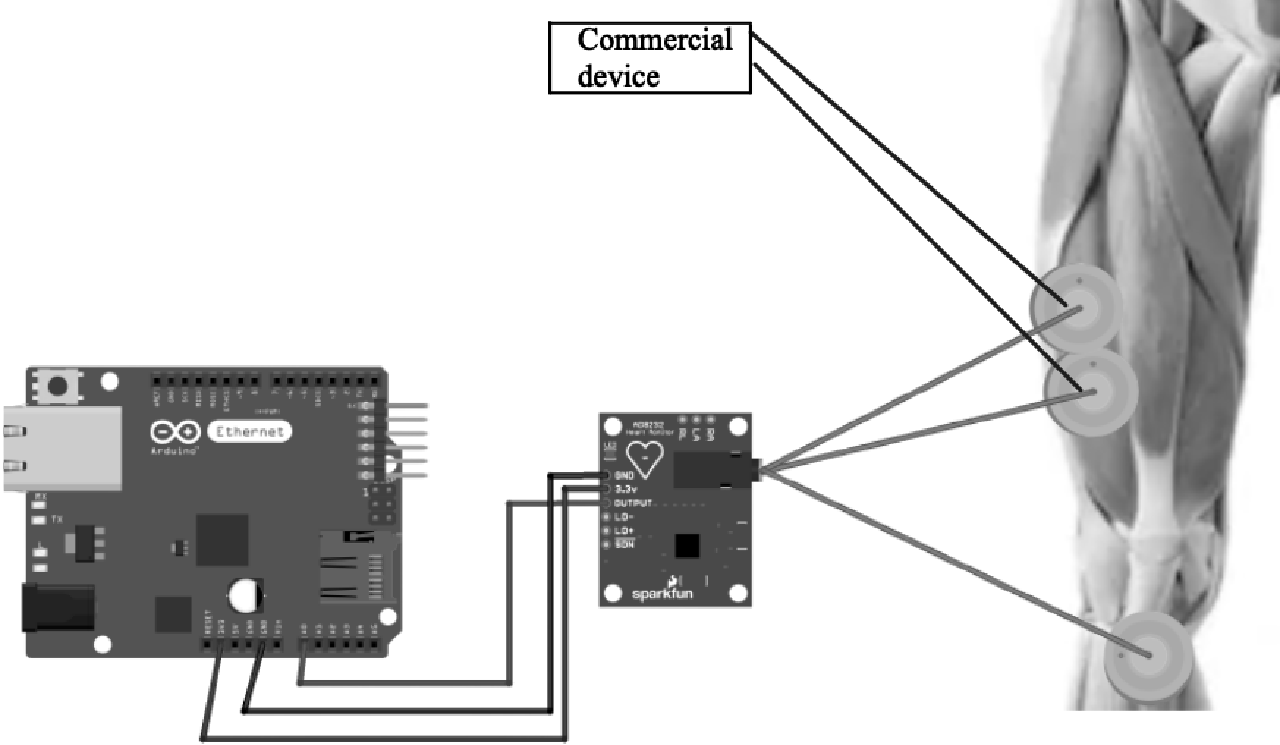

**Figure S1:** the Arduino Uno Ethernet board (on the left) was power up by a 5V external supply. In the middle is the AD8232 sensor with relative connections to the Arduino board (three wires, two for 3.3 V supply and ground and one for the analog amplified signal connected to pin A0). Electrodes were positioned along the vastus lateralis muscle according to SENIAM guidelines.

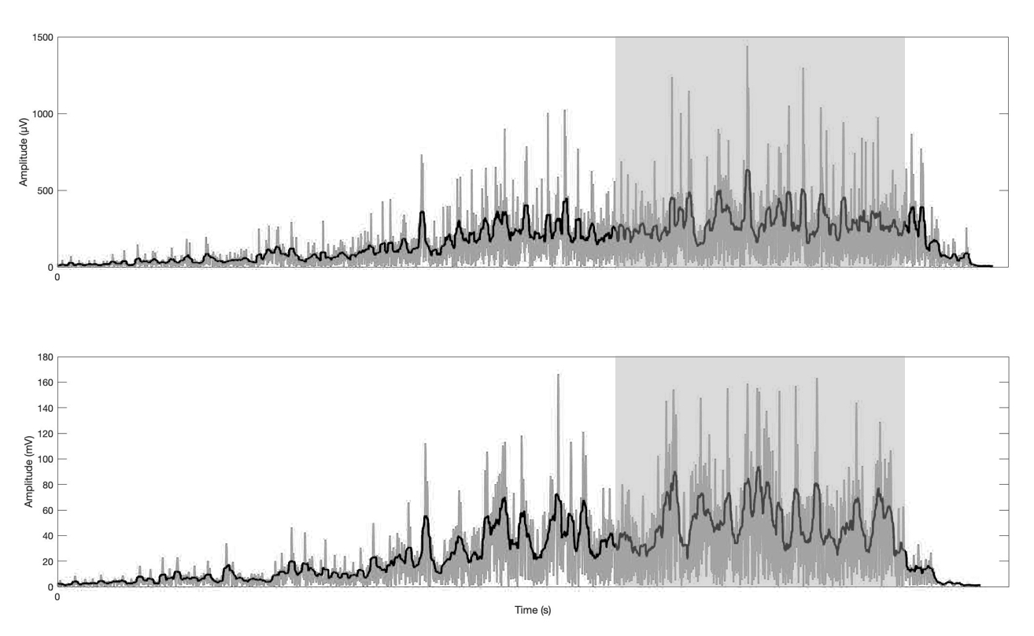

**Figure S2:**example of the same MVC contraction as recorded from both systems. In the upper panel the sEMG signal collected with the commercial system, in the lower panel the one collected with the low-cost system. The grey line is the filtered and rectified signal. The black line identifies the RMS (25 points moving window). The shaded area shows the window (2 s) where RMS mean value was calculated (at steady state).

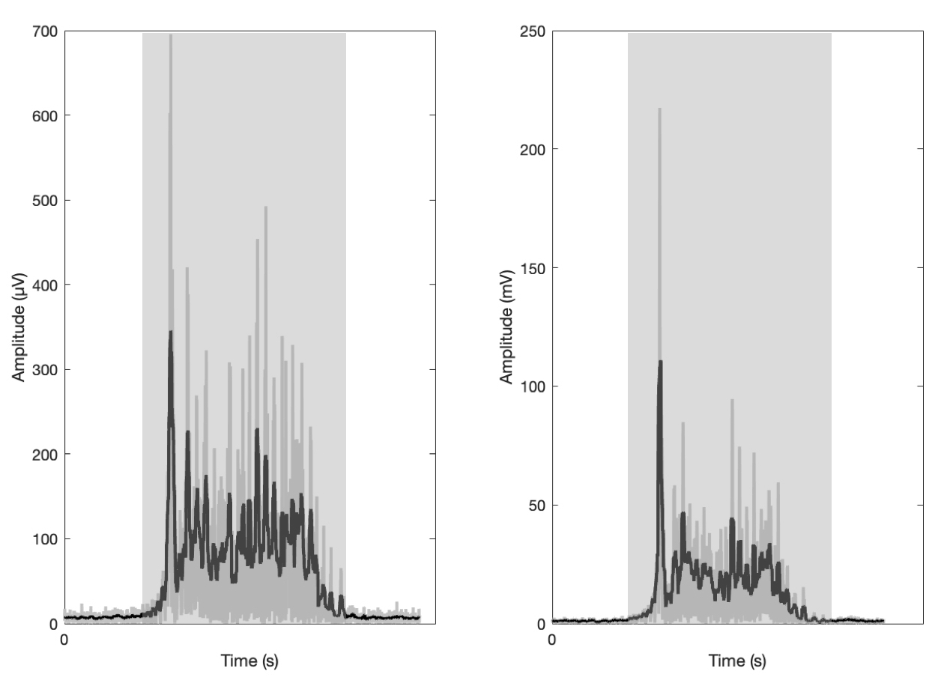

**Figure S3:**example of the same explosive fix-end contraction recorded from both systems. In the left panel the sEMG signal collected with the commercial system, in the right panel the one collected with the low-cost system. The grey line is the filtered and rectified signal. The black line identifies the RMS (25 points moving window). The shaded area shows the activation time where RMS mean value was calculated.